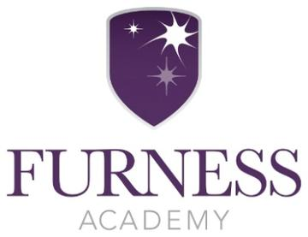
Kickstart
Year 7 Programme June 2021
Questionnaire Data
Have you been affected by the Covid pandemic?
Not at all  20% | A little bit  20% | Quite a lot  20% | Really struggled  40%
Impact of lockdown: Feeling lonely/isolated, missed family and friends, lack confidence in social situations
80% struggled to complete schoolwork during lockdown: Lack of a quiet working space, internet/Wifi issues, work too difficult, needed extra support with work
Since taking part in the Kickstart Programme:
100% Feel more confident
100% Find it easier to talk to other people
100% Try harder to deal with new challenges-not giving up
40% Enjoy working with others
80% Are more confident leading an activity
100% Are more confident sharing ideas and opinions
80% Are more aware of their own strengths and what they are good at
100% Would recommend Kickstart to others
Enjoyed about Kickstart:
‘Playing with my friends’
‘Being with my best friend’
‘How I have seen my strengths and weaknesses’
‘The trip to Kepplewray’
‘Working with my friends’
Ideas to improve Kickstart:
‘Two sessions every week
‘Don’t invite people who give up straight away’
Worries/concerns:
‘If I am able to make friends/make friends last’
‘Working with difficult people’

School staff feedback:

“ The children really enjoyed the activities and the design of the programme . It gave them a valuable break from the routine of school and the confidence they showed on the programme was mirrored in the classroom .They are a very complex group of girls which is why I put them on the program to try and build some friendships. I don’t think the bubble system has helped them being stuck together all day every day “

Thank you for everything you and Kerry do to support our school.

Inspiring Barrow staff feedback:

The girls were a high energy group and have had a difficult year remaining in a teaching bubble throughout. This has had an impact on relationships and dynamics within the group and has caused friction on occasions. The programme has had a positive impact on the children as can been seen in the data above with . Especially pleasing is the 100per cent responses to feeling more confident, easier to take and share ideas and would recommend the programme to others . The girls especially enjoyed their trip to Kepplewray for outdoor activities ( Pics Below )

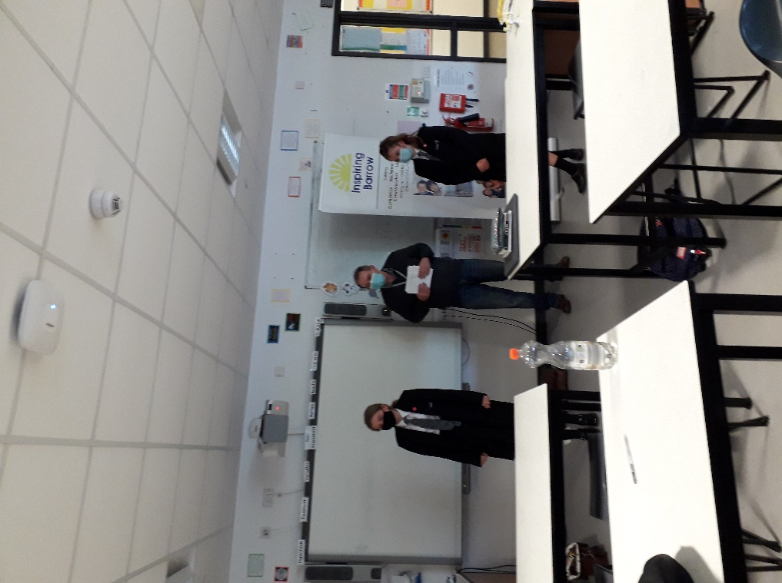
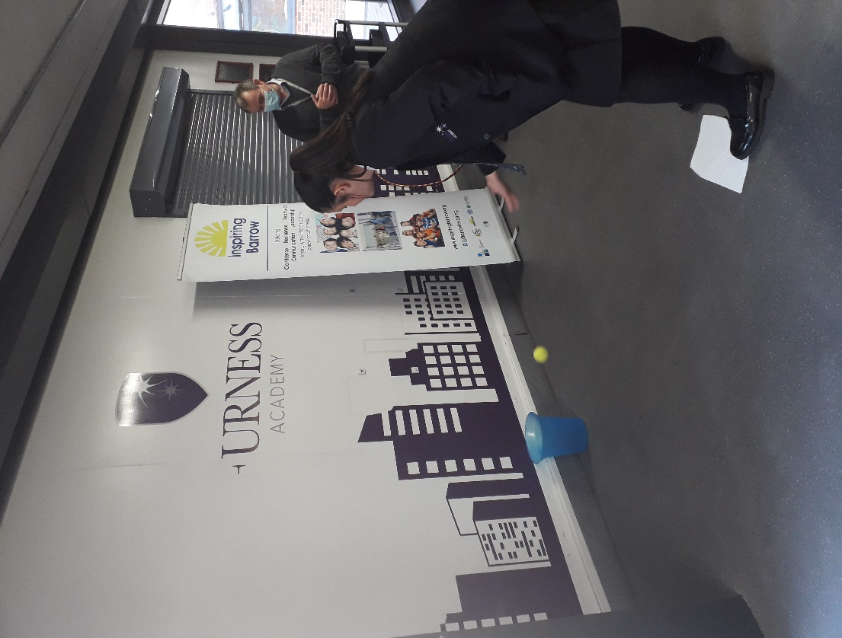
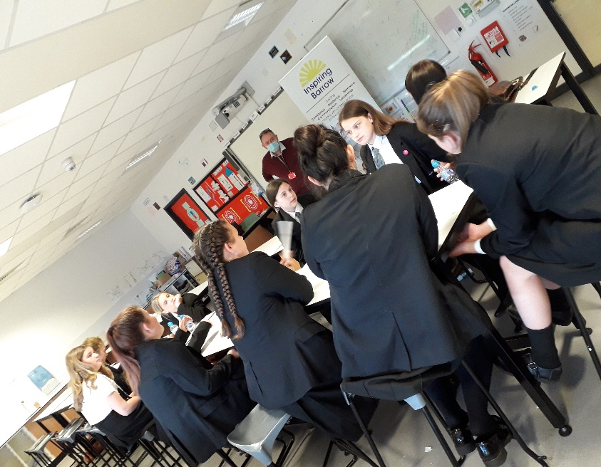
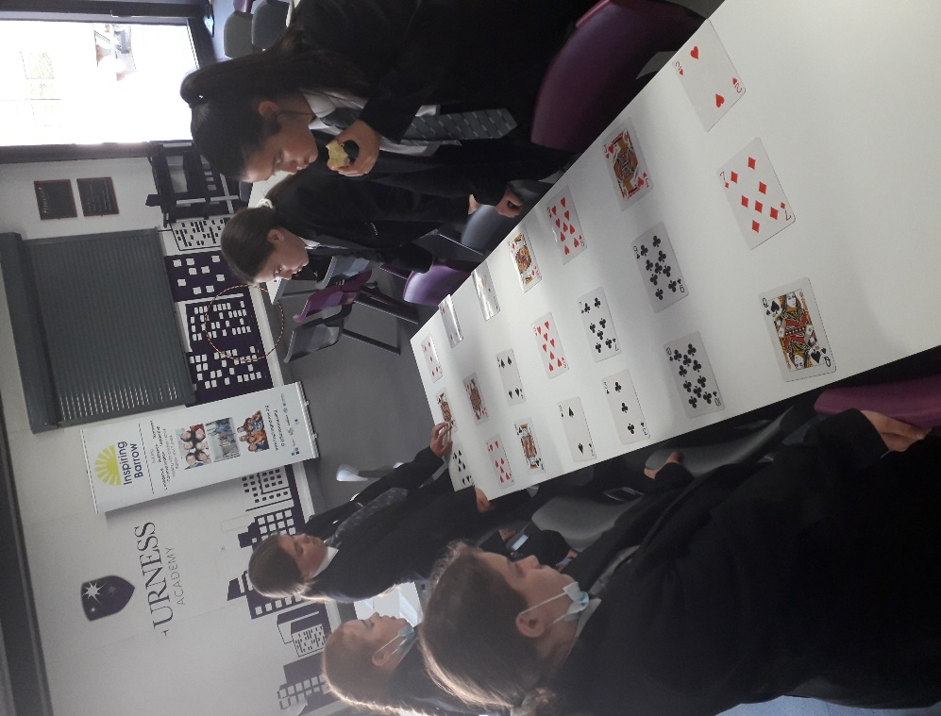
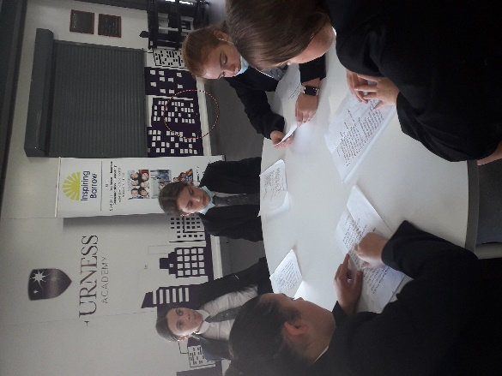
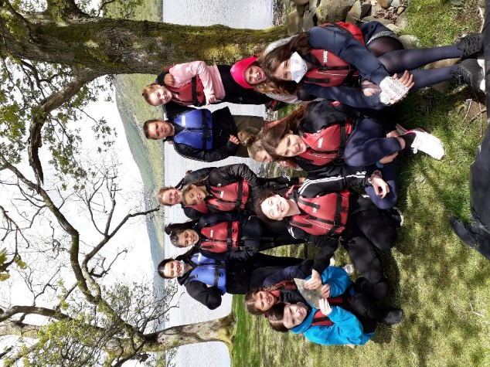
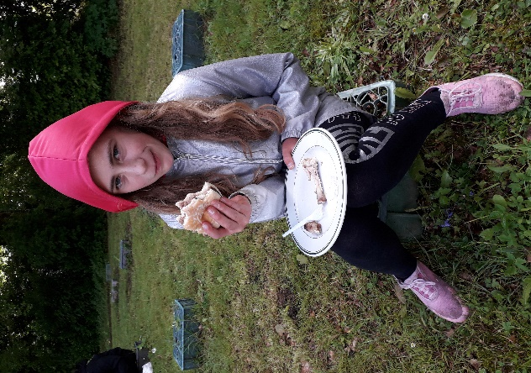
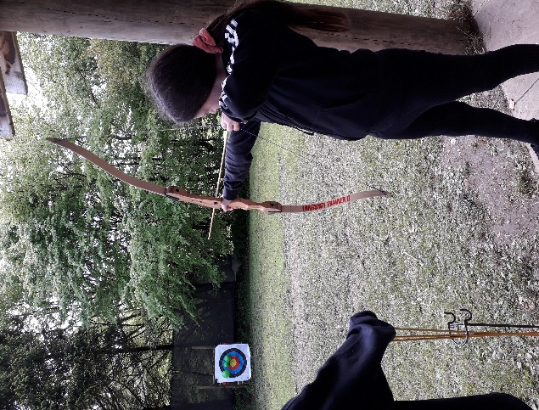
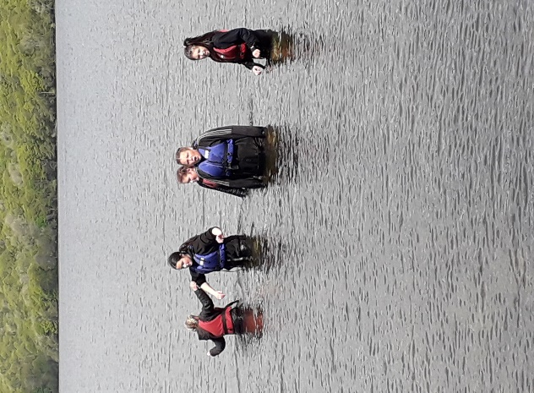
Kickstart Activities

