Kickstart
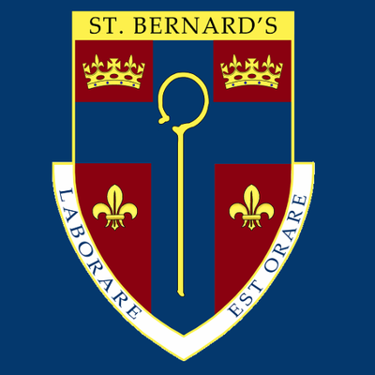
Year 7 Programme June 2021
Questionnaire Data
Have you been affected by the Covid pandemic?
Not at all  33% | A little bit  56% | Quite a lot  11% | Really struggled  0%
Impact of lockdown: Feeling lonely/isolated, missed family and friends, lack confidence in social situations, find it hard to make friends easily
33% struggled to complete schoolwork during lockdown: Keep distracting myself, don’t have my phone all the time, no laptop/resources, work too difficult, needed extra support with work, sharing laptop, internet/Wifi issues
Since taking part in the Kickstart Programme:
89% Feel more confident
44% Find it easier to talk to other people
89% Try harder to deal with new challenges-not giving up
100% Enjoy working with others
33% Are more confident leading an activity
67% Are more confident sharing ideas and opinions
89% Are more aware of their own strengths and what they are good at
100% Would recommend Kickstart to others
Enjoyed about Kickstart:

‘Going on the trip and doing the activities’
‘Going to Kepplewray and sharing my thoughts’
‘Working with others’
‘Making records’
‘Getting to do fun activities’
‘Kepplewray and playing games’
‘Everything!!’
‘The trip’
‘Activities’

Ideas to improve Kickstart:
‘More people invited and more tasks’
Worries/concerns:
‘Going to move around the school’ – stayed in one area of school due to Covid restrictions
‘Moving Year Group’
‘Losing friends and maybe change of uniform in Yr10, change of school/college/Uni’
‘Making new friends, self confidence and talking to people’
‘That I will make mistakes and lead to others loss’

School staff feedback:

‘Over the course of the Kickstart sessions our students visibly relaxed as they grew more confident with one another. The supportive atmosphere allowed them to risk making mistakes without fear of being mocked and they improved at listening to one another as the weeks passed. Some of the students had begun to speak out and take on more of a leadership role which they would not previously have done. Nobody shrank from taking part in anything which they might usually have done.
The trip to Kepplewray firmed up the friendships in the group and the activities demonstrated their increased willingness to work together and support one another.
The group would undoubtedly have enjoyed the final challenge if it had gone ahead and would have benefited from the sense of achievement, but they all seem to have grown from the sessions they were able to attend’ – NB St Bernard’s Catholic High School

‘
Inspiring Barrow staff feedback:

A really good group to work with and have made significant progress since starting Kickstart .
I have seen a huge difference in the students every week growing in confidence and resilience. The peer support that was encouraged really helped with individual self- esteem
Which in turn yielded improved teamwork

Fantastic work by all
DC

