Kickstart
Year 7 Programme June 2021
Questionnaire Data
Have you been affected by the Covid pandemic?
Not at all  17% | A little bit  75% | Quite a lot  8% | Really struggled  0%
Impact of lockdown: Missed family and friends, lack confidence in social situations, find it hard to make friends easily
17% struggled to complete schoolwork during lockdown: Internet/Wifi issues, sharing resources with other family members, lack of a quiet working space
Since taking part in the Kickstart Programme:
100% Feel more confident
83% Find it easier to talk to other people
92% Try harder to deal with new challenges-not giving up
92% Enjoy working with others
75% Are more confident leading an activity
83% Are more confident sharing ideas and opinions
92% Are more aware of their own strengths and what they are good at
100% Would recommend Kickstart to others
Enjoyed about Kickstart:
‘Just the feeling of accomplishing things’
‘The games’
‘The food, activities and people in it’
‘The activities’
‘Making new friends’
‘I enjoyed all the activities we did as a team’
‘Everything’
‘Working as a team’
‘The games were fun. It was great to meet new people and make new friends’
‘Having fun, away from school’

Ideas to improve Kickstart:
‘I can’t think of anything’
‘Chocolate’
‘More creative’
‘No, it’s great!’
‘Wider range of activities’
It’s all good, you could make the trip longer’

Worries/concerns:
‘I am moving away so will miss my friends’
‘Making new friends/meeting new people’
‘Covid coming back, and my Mum’
‘Change’
‘I am scared my family will get Covid’
‘Biology and Mrs A’

School staff feedback:

‘Thanks for this excellent feedback. Kickstart will have made a great difference to these children immediately and in ways they may not realise until a few years down the line’

‘Listening to their enthusiasm and animated voices made my day. These are the things that make schools about much more than exam results.

‘The joyful sounds I hear from the dining room say it all. Many thanks to you and Kerry’

SH – Deputy Head Teacher

‘How wonderful to receive such a positive email! I watched through the window as I was leaving, they looked like they were having a great time’ – KJ Head of Year

Inspiring Barrow staff feedback:

The children of Ulverston Victoria High School were extremely well together and had a a high attendance throughout the programme. A mixed group of boy’s and girls of mixed ability used their skills to work together to harness the best outcomes. This proved extremely successful in the final challenge which they completed.
A great group again reporting 100 per cent improved confidence and high resilience and teamworking Well done !!

Dave

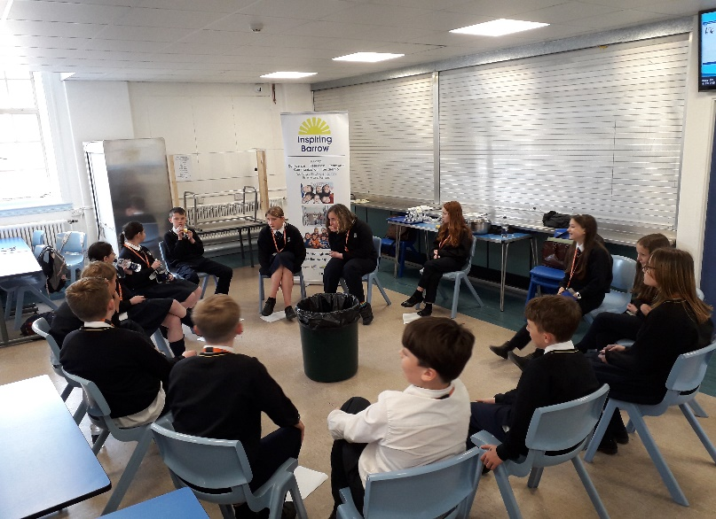
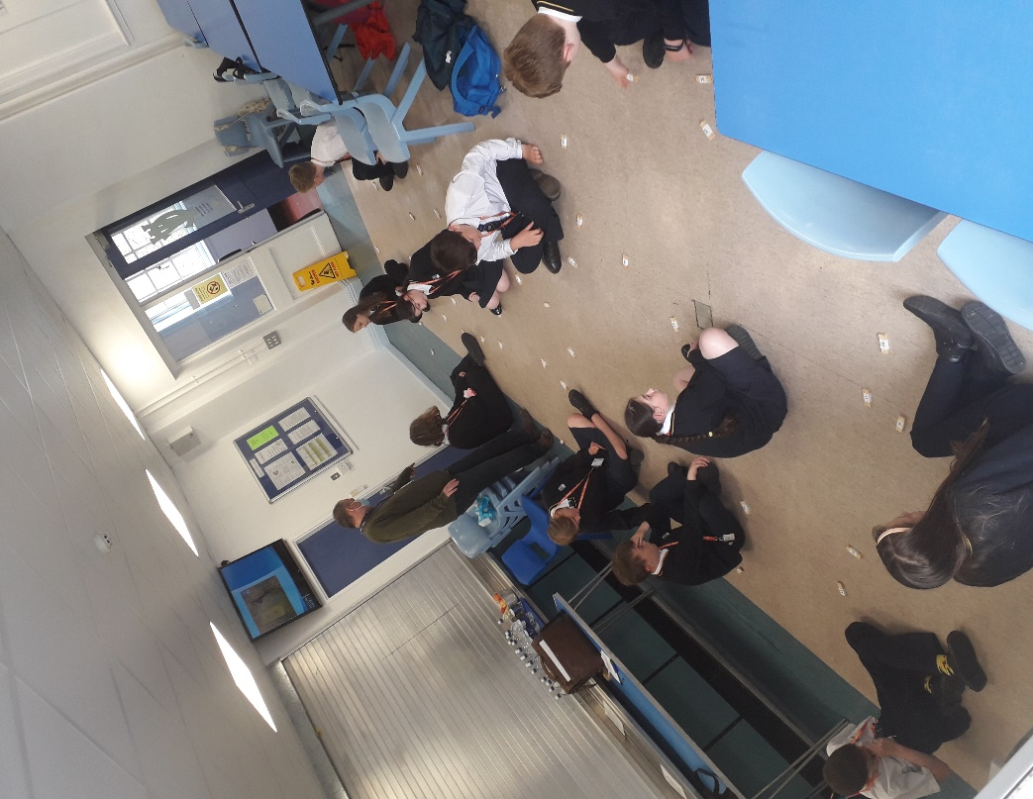
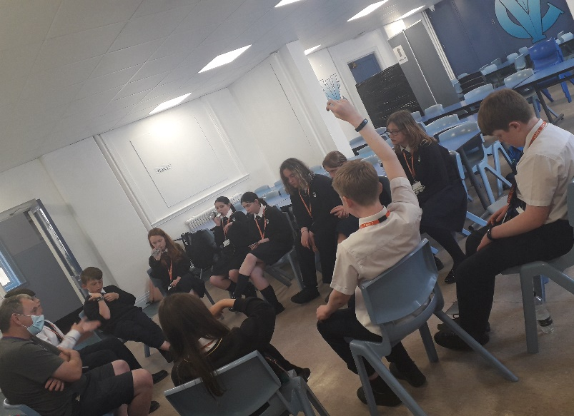
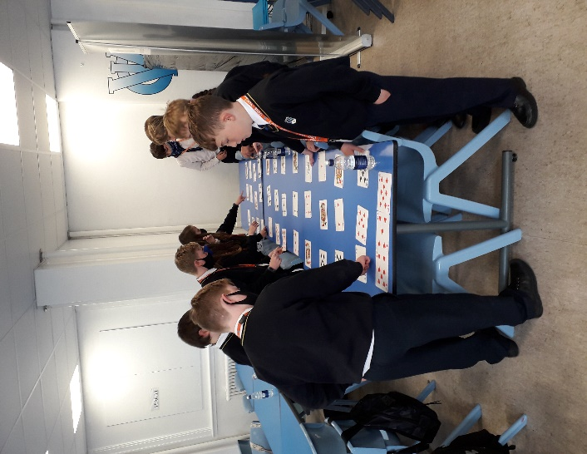
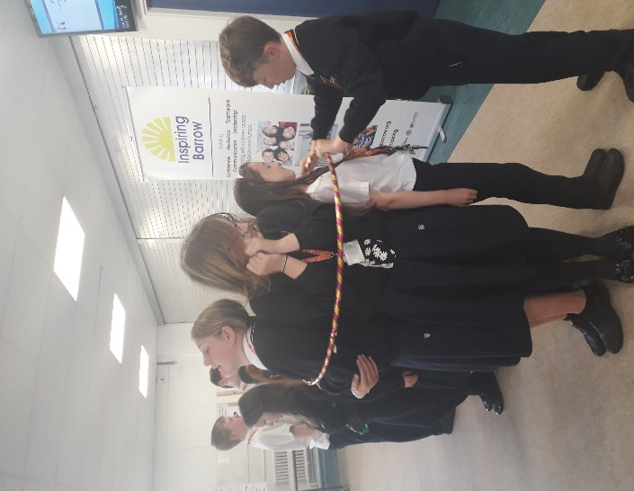
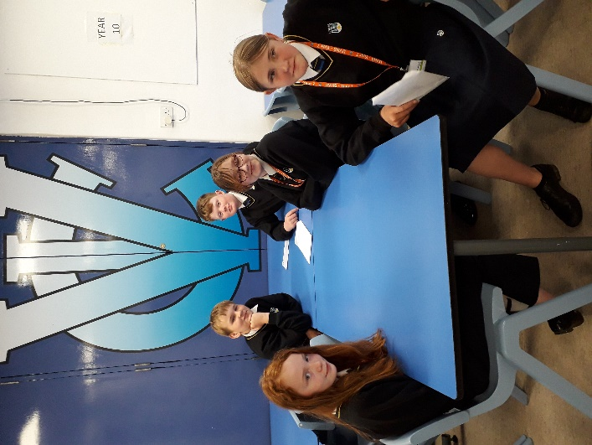

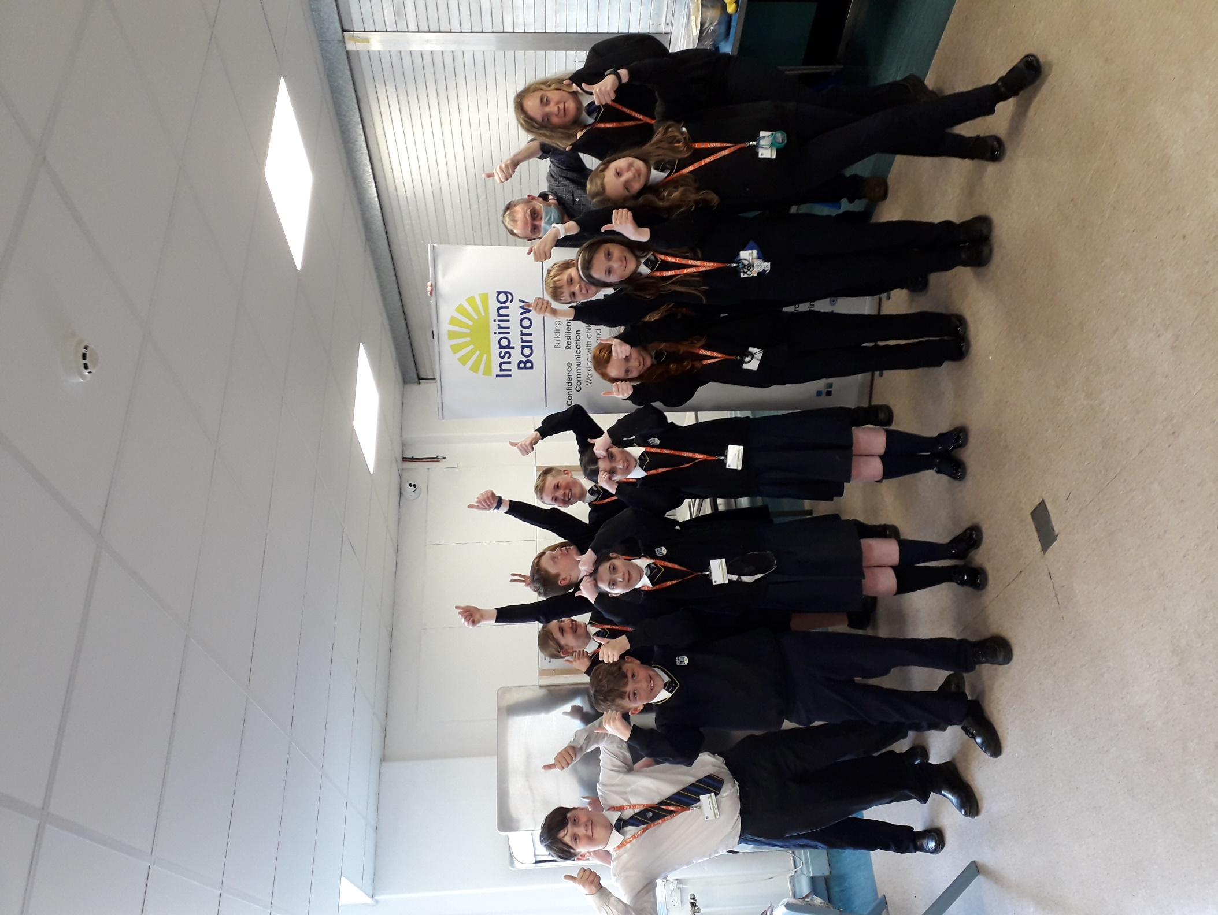
Kickstart ‘FINAL CHALLENGE’
‘WE DID IT’

WE

