Kickstart
Year 7 Programme June 2021
Questionnaire Data
Have you been affected by the Covid pandemic?
Not at all  8% | A little bit  67% | Quite a lot  25% | Really struggled  0%
Impact of lockdown: Feeling lonely/isolated, missed family and friends, lack confidence in social situations, find it hard to make friends easily
42% struggled to complete schoolwork during lockdown: Lack of a quiet working space, internet/Wifi issues, work too difficult, needed extra support with work, sharing laptop, Nanna worked and couldn’t access ‘showbie’
Since taking part in the Kickstart Programme:
83% Feel more confident
75% Find it easier to talk to other people
83% Try harder to deal with new challenges-not giving up
92% Enjoy working with others
58% Are more confident leading an activity
58% Are more confident sharing ideas and opinions
83% Are more aware of their own strengths and what they are good at
100% Would recommend Kickstart to others
Enjoyed about Kickstart:
‘All of it’
‘Everything’
‘Having fun’
‘Making new friends’
‘People working together’
‘The card games’
‘It’s not boring’
‘Teamwork and making new friends’
‘Making new friends and building my confidence’
Ideas to improve Kickstart:
‘Helping people to listen to others’
‘Nothing, it’s perfect’
‘No, it’s really good as it is’
Worries/concerns:
‘Presenting in front of a lot of people’
‘Doing online learning again’
‘Not being confident’
School staff feedback:

‘Thanks so much for such wonderful feedback! They really are getting so much out of the programme and it's great to hear them talking about the activities and challenges they've been doing. It's bringing them on brilliantly!’ PM – Head of Year

‘Thank you for this lovely feedback.The work that both you and Dave are doing with children across the Furness area through Kickstart is brilliant.
Many thanks for once again delivery a great programme to Walney kids.’ JR – Head Teacher

‘It was lovely to watch them for a few minutes and how supportive they were of each other.
The atmosphere in the room was amazing especially when TJ caught the jenga block first time 😊
I teach and work with many of those pupils, it certainly was lovely to see.’ KF - SENCO

Inspiring Barrow staff feedback:

15x Year 7 students were invited on to the programme, all of mixed ability and gender. Attendance to each session was excellent, with 14 completing the whole programme.
Each week students completed the set challenges with an enthusiastic approach and were observed interacting and supporting each other throughout. Students were encouraged to elect a ‘leader’ for each activity, to ensure everyone was included and felt valued.
The build up to the final session was met with great excitement and students were determined they were going to complete ‘The Final Challenge’. And they certainly didn’t disappoint! While they found the session tough and frustrating, they ALL rose to the challenge and never once wanted to give up. The elation on their faces when they finished with seconds to spare…was amazing! Clearly very proud of themselves and of each other.
What really impressed me, was a couple of students, who had a little wobble at the very start…were supported, encouraged, included and returned back to the activities to help their team.

Really looking forward to our visit to Kepplewray on 6th July for a day of outdoor activities
They deserve it!

Kerry

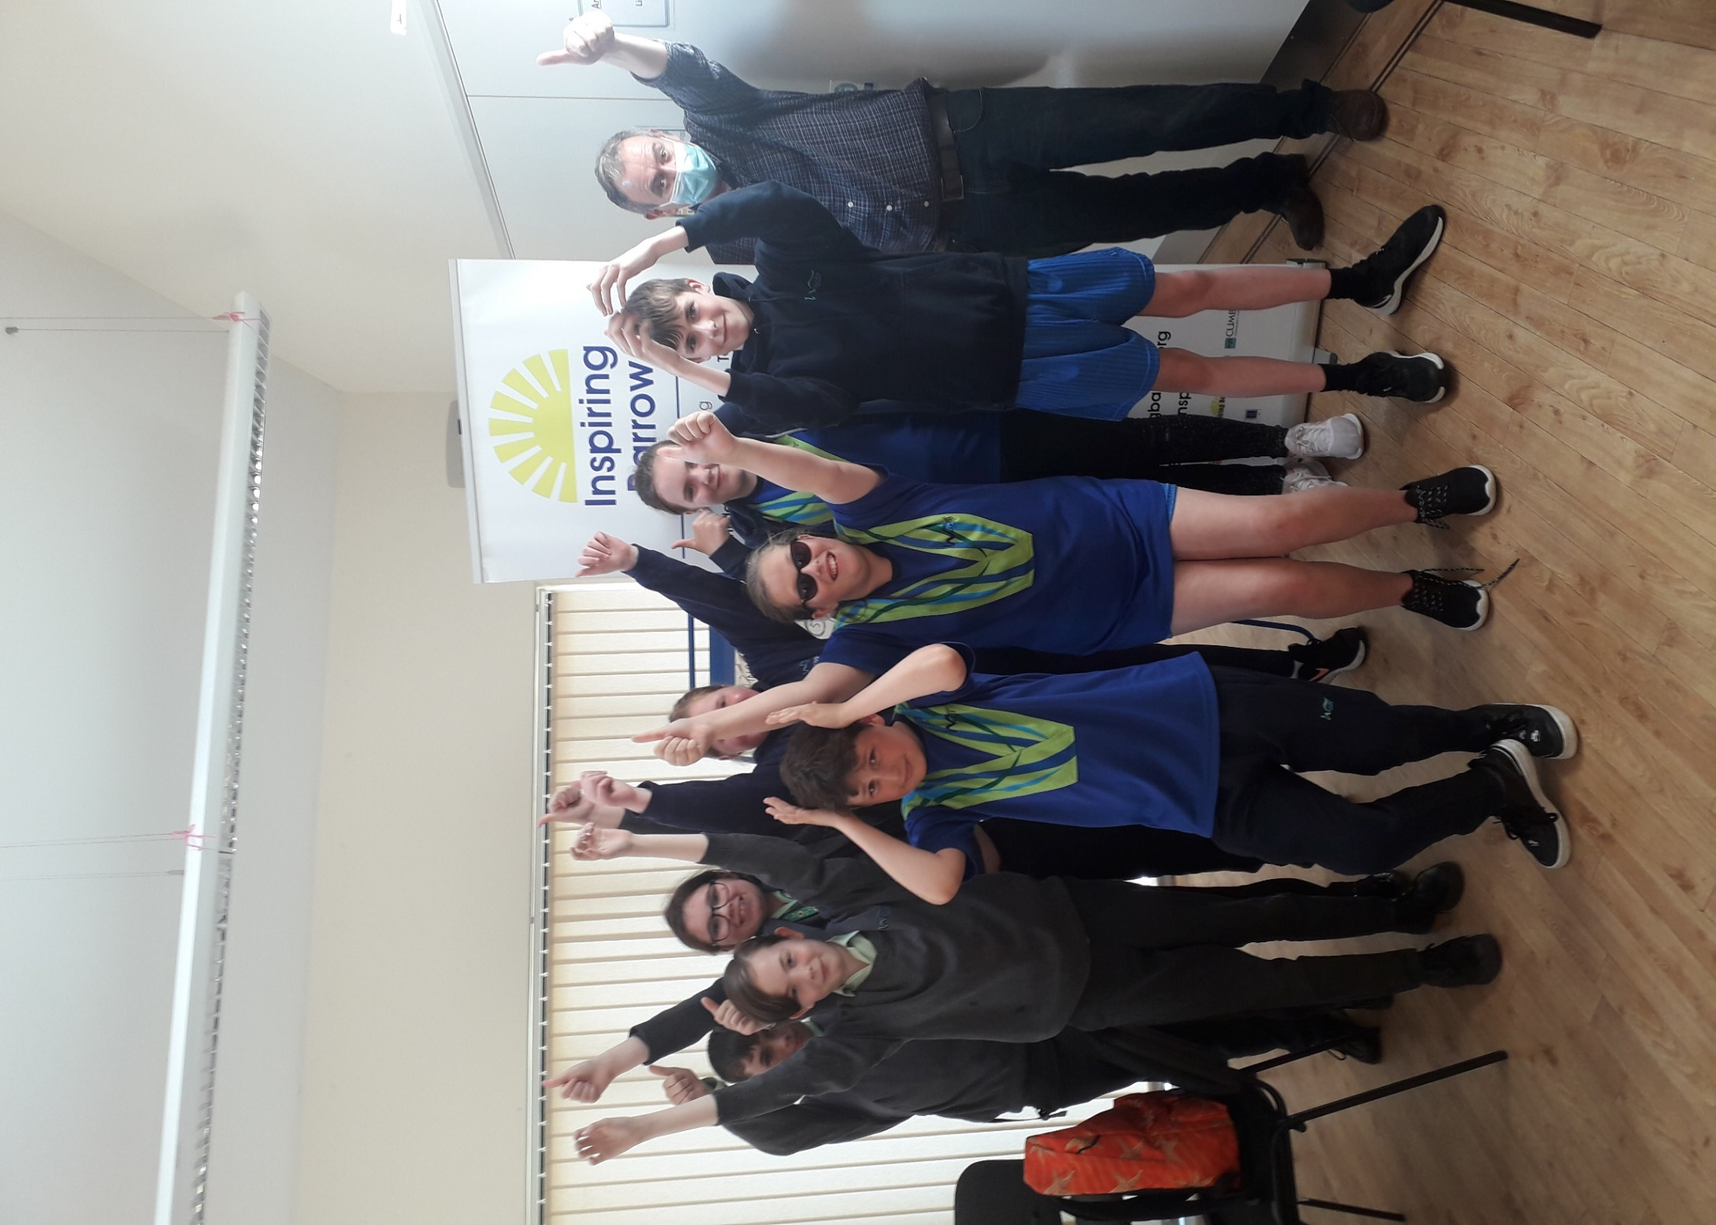
Kickstart ‘FINAL CHALLENGE’
‘WE DID IT’

WE

Just some of the fantastic Year 7 Kickstart students at Walney School
(Some students not photographed due to photo consent BUT just as fab!)

